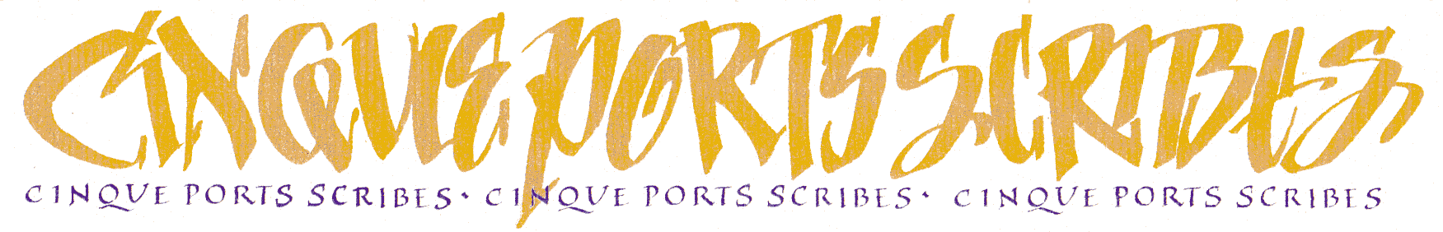
MEMBERSHIP FORM

Name ….....................................................................................................................................................................

Address …..................................................................................................................................................................

…................................................................................................. Postcode …............................................................

Email ….................................................................................... Preferred tel no …..................................................

Joining / Renewing please circle as appropriate

Payment please tick as appropriate
□ January – December £20 □ August – December £10
Payment method please tick as appropriate
□ BACS preferred method
Account Name: Cinque Ports Scribes Sort Code: 30-90-28 Account Number 01503554
□ CHEQUE
Make payable to Cinque Ports Scribes (not CPS) and post this form + cheque to our Treasurer, Diane Sutton, 17 Shalmsford Street, Chartham, Canterbury, Kent, CT4 7RZ
For either method, give your name as reference and advise Treasurer on treasurer@cinqueportsscribes.org.uk

Other Information please tick as many as appropriate
How did you hear about CPS? ...................................................................................................................................
Level of experience □ Beginner □ More experienced
Please list any particular areas of interest for your calligraphy .................................................................................
....................................................................................................................................................................................
□ I am a member of the Calligraphy and Lettering Arts Society (CLAS)
□ I am a member of The Society of Scribes and Illuminators (SSI)
□ I am a tutor
□ I would like to receive teaching requests
□ I would like my classes on the CPS website and in SCRIBO (send details to info@cinqueportsscribes.org.uk)
□ I would like to receive details on commissions
□ I would like to receive details of other area groups, CLAS, SSI etc
□ I would like to receive details for the possibility of exhibiting my work

We will contact you by email in all instances unless specifically requested otherwise

GDPR
We will only use your details to send you SCRIBO, information on CPS events and administration including the AGM.
We will not share your personal details with any other body unless prior agreement has been given by you.
For details please see our GDPR Policy on the website cinqueportsscribes.org.uk

CONSENT
I give consent to Cinque Ports Scribes to publish, republish or otherwise transmit photographs for the purposes of publicity and promotional materials, including advertising material and printed publications, websites, social media channels and digital communications materials, presentation and exhibition materials.
Signed Date
23.10.2024

